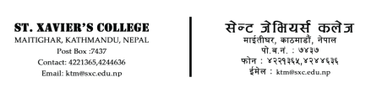

**DEPARTMENT OF COMPUTER SCIENCE**

**IT 245: BUSINESS INFORMATION SYSTEMS**

**SUBMITTED BY:**

Sayujya Satyal

021BIM054

6th Semester - Section B

TU Roll: 13417/21

**SUBMITTED TO:**

Department of Computer Science

St. Xavier’s College

Maitighar, Kathmandu